create table category_details(category_id numeric (2),category_name varchar (30));

create table sub_category_details(sub_category_id numeric (2),category_id numeric (2),sub_category_name varchar (30));

create table product_details(product_id numeric (6),category_id numeric (2),sub_category_id numeric (2),product_name varchar (30));

1).
alter table category_details
add primary key(category_id);

2).
alter table sub_category_details
add constraint subcatid_pk primary key (sub_category_id);

3).
alter table sub_category_details
add constraint catid_fk foreign key (category_id) references category_details (category_id);

4).
alter table product_details
add constraint proid_pk primary key (product_id);

alter table product_details
add constraint catid_fk foreign key (category_id) references category_details(category_id);

alter table product_details
add constraint subcatid_fk foreign key (sub_category_id) references sub_category_details(sub_category_id);

5).
alter table product_details
add column price numeric (2);

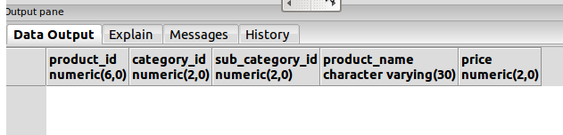

6).
alter table product_details
alter column price type numeric (6,2);
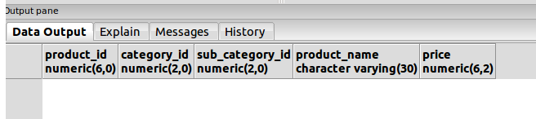

7).
insert into category_details
values(22,'Cosmatics');

insert into category_details
values(44,'Food Products');

insert into category_details
values(33,'Kitchen Appliances');

insert into category_details
values(55,'Everyday Use');

category_details table :-
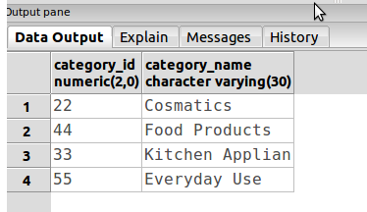

insert into sub_category_details
values(20,33,'Pans & vessels');

insert into sub_category_details
values(56,22,'Sahmpoo');

insert into sub_category_details
values(40,22,'Hair Conditioner');

insert into sub_category_details
values(70,33,'Serving Ware');

sub_category_details table :-
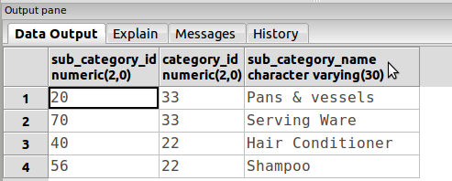

insert into product_details
values(234,22,56,'Clean & CLear',56.7);

insert into product_details
values(467,22,40,'Garnier',65.2);

insert into product_details
values(730,22,56,'Nevia',75.2);

insert into product_details
values(679,22,40,'Dove',65.2);

product_details table :-
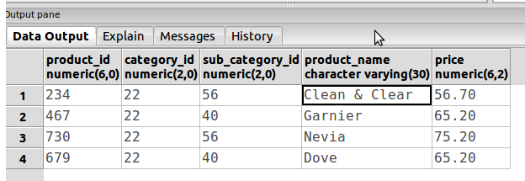

8).
alter table product_details
drop price;

9).
alter table product_details
add column BRAND_NAME varchar (20);

alter table product_details
add constraint bnam_pro_nn not null (BRAND_NAME);

10).
alter table Category_details
rename to Cat_dt;

